Ultrasonic Sensor

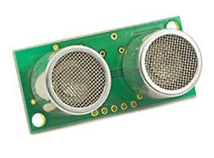

The Parallax PING))) ultrasonic distance sensor provides precise, non-contact distance measurements from about 2 cm (0.8 inches) to 3 meters (3.3 yards). It is very easy to connect to BASIC Stamp® or Javelin Stamp microcontrollers, requiring only one I/O pin. The PING))) sensor works by transmitting an ultrasonic (well above human hearing range) burst and providing an output pulse that corresponds to the time required for the burst echo to return to the
Sensor. By measuring the echo pulse width the distance to target can easily be calculated

Features:

• Supply Voltage – 5 VDC
• Supply Current – 30 mA typ; 35 mA max
• Range – 2 cm to 3 m (0.8 in to 3.3 yrds)
• Input Trigger – positive TTL pulse, 2 uS min, 5 μs typ.
• Echo Pulse – positive TTL pulse, 115 uS to 18.5 ms
• Echo Hold-off – 750 μs from fall of Trigger pulse
• Burst Frequency – 40 kHz for 200 μs
• Burst Indicator LED shows sensor activity
• Delay before next measurement – 200 μs
• Size – 22 mm H x 46 mm W x 16 mm D (0.84 in x 1.8 in x 0.6 in)

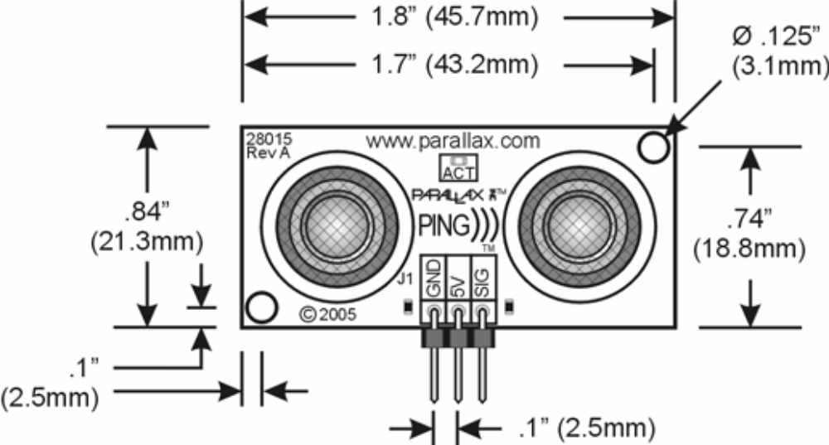

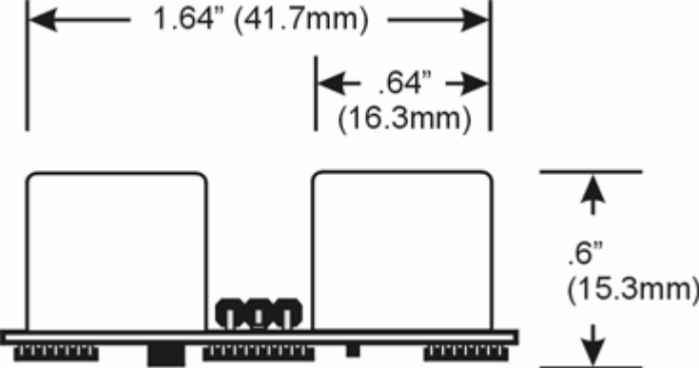

Pin Definitions:

GND Ground (Vss) 5 V 5 VDC (Vdd) SIG Signal (I/O pin) The PING))) sensor has a male 3-pin header used to supply power (5 VDC), ground, and signal. The header allows the sensor to be Plugged into a solder less breadboard, or to be located remotely Through the use of a standard servo extender cable (Parallax part #805-00002). Standard connections are show in the diagram to The right.

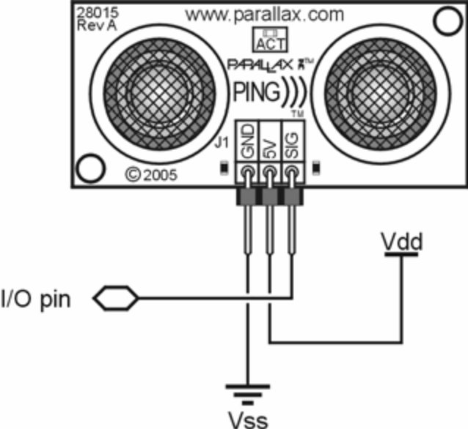

Quick-Start Circuit:

This circuit allows you to quickly connect your PING))) sensor to a BASIC Stamp® 2 via the Board of Education® breadboard area. The PING))) module’s GND pin connects to Vss, the 5 V pin connects to Vdd, and the SIG pin connects to I/O pin P15. This circuit will work with the example program Ping_Demo.BS2 listed on page 7.

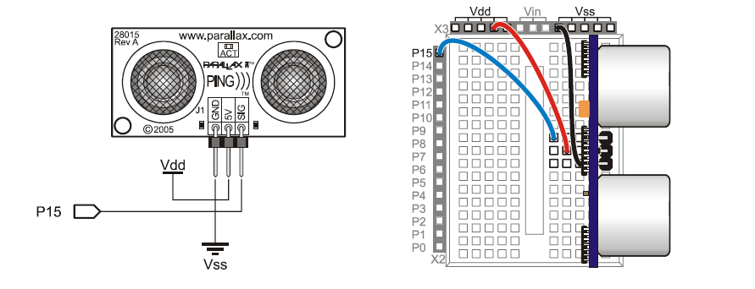
Servo Cable and Port Cautions:

If you want to connect your PING))) sensor to a Board of Education Using a servo extension cable, follow these steps:
- when plugging the cable onto the PING))) sensor, connects Black to GND, Red to 5 V, and White to SIG.
- Check to see if your Board of Education servo ports have a jumper, as shown at right.
- If your Board of Education servo ports have a jumper, set it to Vdd as shown.
- If your Board of Education servo ports do not have a jumper, do not use them with the PING))) sensor. These ports only provide Vin, not Vdd, and this may damage your PING))) sensor. Go to the next step.
- Connect the servo cable directly to the breadboard with a 3-pin header. Then, use jumper wires to connect Black to Vss, Red to Vdd, and White to I/O pin P15.
Theory of Operation:

The PING))) sensor detects objects by emitting a short ultrasonic burst and then "listening" for the echo. Under control of a host microcontroller (trigger pulse), the sensor emits a short 40 kHz (ultrasonic) burst. This burst travels through the air at about 1130 feet per second, hits an object and then bounces back to the sensor. The PING))) sensor provides an output pulse to the host that will terminate when the echo is detected; hence the width of this pulse corresponds to the distance to the target.

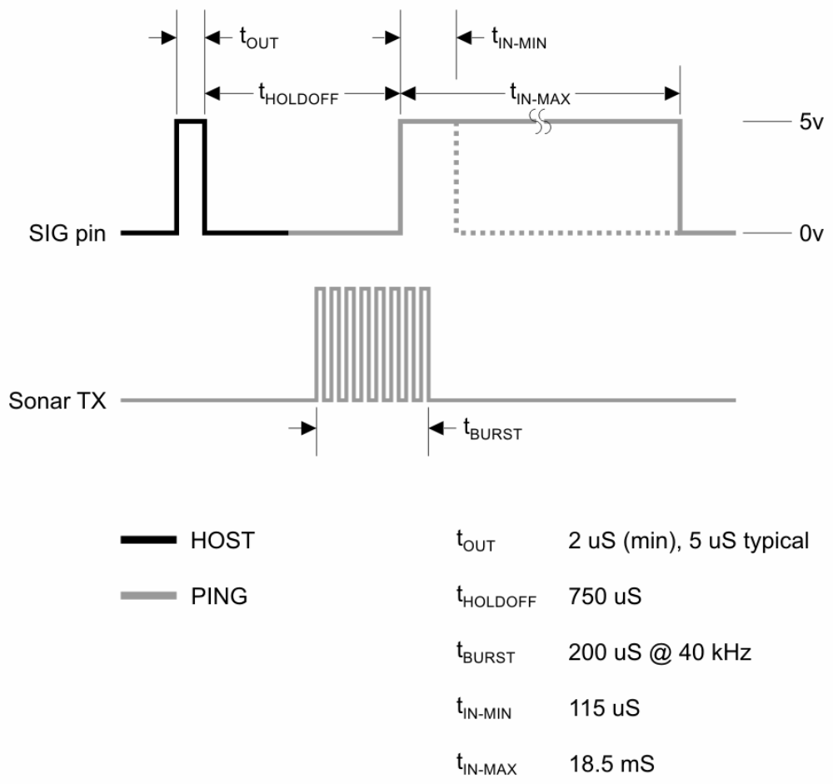
Test Data:
The test data on the following pages is based on the PING))) sensor, tested in the Parallax lab, while connected to a BASIC Stamp microcontroller module. The test surface was a linoleum floor, so the sensor was elevated to minimize floor reflections in the data. All tests were conducted at room temperature, indoors, in a protected environment. The target was always centered at the same elevation as the PING))) sensor. Sensor Elevation: 40 in. (101.6 cm) Target: 3.5 in. (8.9 cm) diameter cylinder, 4 ft. (121.9 cm) tall – vertical orientation
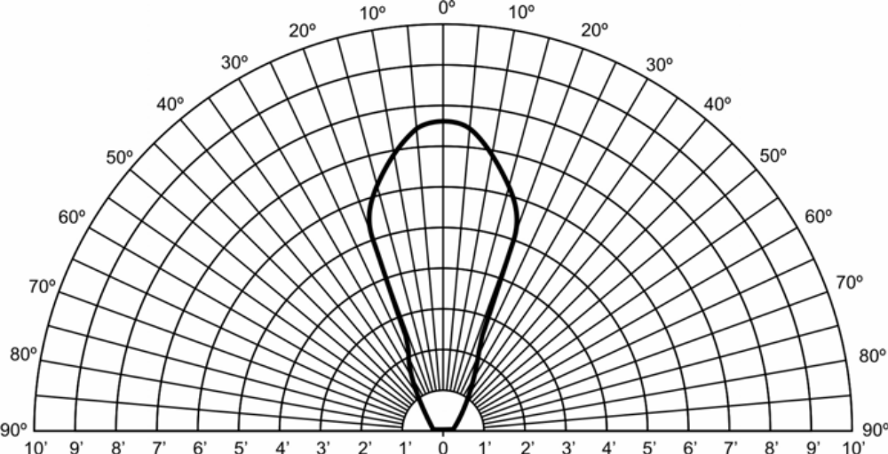

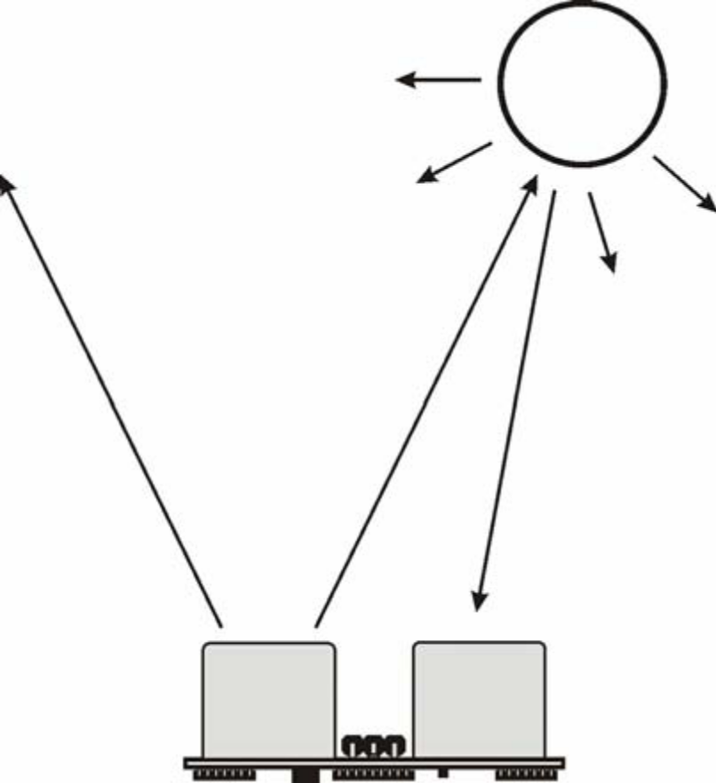
Test 2:

Sensor Elevation: 40 in. (101.6 cm)
Target: 12 in. x 12 in. (30.5 cm x 30.5 cm) cardboard, mounted on 1 in. (2.5 cm) pole
● Target positioned parallel to backplane of sensor

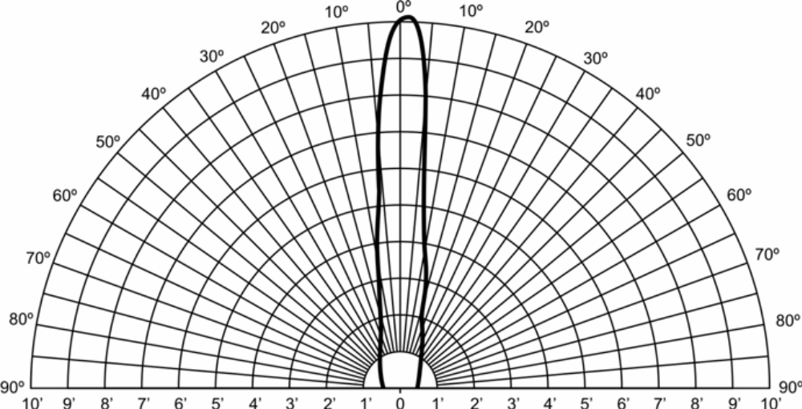

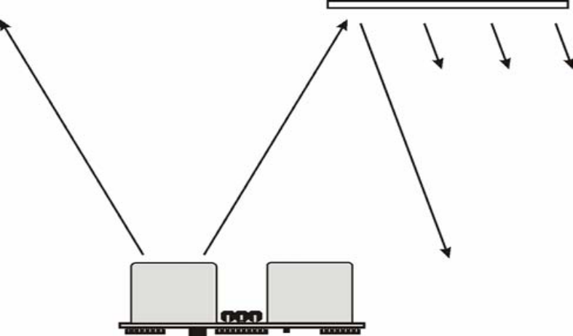

The following program demonstrates the use of the PING))) sensor with the BASIC Stamp 2 microcontroller. Any model of BASIC Stamp 2 module will work with this program as conditional compilation techniques are used to make adjustments based on the module that is connected. The heart of the program is the Get Sonar subroutine. This routine starts by making the output bit of the selected IO pin zero – this will cause the successive PULSOUT to be low-high-low as required for triggering the PING))) sensor. After the trigger pulse falls the sensor will wait about 200 microseconds before transmitting the ultrasonic burst. This allows the BS2 to load and prepare the next instruction. That instruction, PULSIN, is used to measure the high-going pulse that corresponds to the distance to the target object. The raw return value from PULSIN must be scaled due to resolution differences between the various members of the BS2 family. After the raw value is converted to microseconds, it is divided by two in order to remove the "return trip" of the echo pulse.
The value now held in rawDist is the distance to the target in microseconds. Conversion from microseconds to inches (or centimeters) is now a simple matter of math. The generally accepted value for the speed-of-sound is 1130 feet per second. This works out to 13,560 inches per second or one inch in 73.746 microseconds. The question becomes, how do we divide our pulse measurement value by the floating-point number 73.746? Another way to divide by 73.746 is to multiply by 0.01356. For new BASIC Stamp users this may seem a dilemma but in fact there is a special operator, **, that allows us to do just that. The ** operator has the affect of multiplying a value by units of 1/65,536. To find the parameter for ** then, we simply multiply 0.01356 by 65,536; the result is 888.668 (we'll round up to 889). Conversion to centimeters.

